Data Visualization: Empowering Business with Effective Insights

**Task 1: Framing the Business Scenario**

# Here is the background information on your task

An online retail store has hired you as a consultant to review their data and provide insights that would be valuable to the CEO and CMO of the business. The business has been performing well and the management wants to analyse what the major contributing factors are to the revenue so they can strategically plan for next year.

The leadership is interested in viewing the metrics from both an operations and marketing perspective. Management also intends to expand the business and is interested in seeking guidance into areas that are performing well so they can keep a clear focus on what’s working. They would also like to view different metrics based on the demographic information that is available in the data.

A meeting with the CEO and CMO has been scheduled for next month and you need to draft the relevant analytics and insights that would help evaluate the current business performance and suggest metrics that would enable them to make the decision on expansion.

Remember, thinking from the perspective of business leaders allows you to analyse the data more effectively and present better insights.

Access the links in the resources below to better understand how business leaders think and approach business performance.

# Here is your task

To prepare for your meeting, you need to draft questions that you think will be important and relevant to the CEO and CMO. This preparation will be your guide as you develop your presentation.

For this task, you are only required to draft the questions. Make sure to think both quantitatively and qualitatively.

You’ve been provided a dataset in the resources below to use as the basis for your exploration. Review this data, taking note of what information has been provided, what insights you can garner, and what is relevant to both the CEO and CMO respectively.

Create a set of four questions that you anticipate each business leader will ask and want to know the answers to. Make sure you differentiate your questions, as both the CEO and CMO view business decisions through different lenses.

Submit your eight questions in total (4 for the CEO and 4 for the CMO) in the text submission box below.

## 

## Here are some resources to help you

**[Dataset](https://cdn.theforage.com/vinternships/companyassets/ifobHAoMjQs9s6bKS/5XsFFJu2oCLdmYJW2/1654128941410/Online%20Retail.xlsx)**

**[Click to download file →](https://cdn.theforage.com/vinternships/companyassets/ifobHAoMjQs9s6bKS/5XsFFJu2oCLdmYJW2/1654128941410/Online%20Retail.xlsx)**

Available from: Daqing Chen, Sai Liang Sain, and Kun Guo, Data mining for the online retail industry: A case study of RFM model-based customer segmentation using data mining, Journal of Database  
Marketing and Customer Strategy Management, Vol. 19, No. 3, pp. 197â€“208, 2012  
(Published online before print: 27 August 2012. doi: 10.1057/dbm.2012.17).  
(https://archive.ics.uci.edu/ml/about.html)

**[Asana - Article on metrics you should be tracking](https://asana.com/resources/success-metrics-examples)**

[**Click to view website →**](https://asana.com/resources/success-metrics-examples)

**[Scoro - Article on metrics that every company should know](https://www.scoro.com/blog/12-business-metrics/)**

**[Click to view website →](https://www.scoro.com/blog/12-business-metrics/)**

### **Questions for the CEO (Operations-focused, strategic decision-making):**

1. **What are the top-performing product categories in terms of revenue, and how do these align with the current market trends?**
   * This question will help the CEO understand which products are contributing most to the business’s success and whether the business should focus on expanding or doubling down on these categories.
2. **How does customer segmentation impact revenue growth, and which customer segments are the most profitable?**
   * The CEO will be interested in understanding how customer behaviors and preferences are affecting the bottom line and which segments could provide the most return if the business expands or adjusts its operations.
3. **What are the operational inefficiencies or bottlenecks in the current order fulfillment process that may be impacting customer satisfaction or revenue?**
   * Addressing operational bottlenecks is crucial for the CEO as it helps streamline business operations, reduce costs, and improve revenue margins.
4. **What are the operational inefficiencies or bottlenecks in the current order fulfillment process that may be impacting customer satisfaction or revenue?**
   * This question helps assess customer retention and the sustainability of business growth, allowing the CEO to plan for future investments or strategic changes.

### **Questions for the CMO (Marketing-focused, customer acquisition and brand growth):**

1. **Which marketing channels are driving the highest ROI in terms of customer acquisition, and how can we optimize these efforts for the coming year?**
   * The CMO will need to know which marketing campaigns or channels (e.g., email, social media, PPC) are generating the most customers and revenue, to help focus the marketing budget effectively.
2. **How does customer demographic data correlate with purchasing behavior, and are there any underutilized demographic segments that present opportunities for marketing growth?**
   * This question will help the CMO understand how demographic segments are performing and whether there are untapped opportunities for targeting certain groups with personalized campaigns.
3. **What role do promotions and discounts play in driving sales, and how do they impact customer retention and long-term profitability?**
   * Understanding the effectiveness of discounts and promotions will allow the CMO to adjust strategies for customer acquisition and retention while balancing profitability.
4. **How can we improve customer engagement and brand loyalty through personalized marketing, and what metrics should we track to measure success?**
   * The CMO will be interested in exploring how personalized marketing initiatives, like targeted ads or loyalty programs, can improve customer satisfaction and drive long-term revenue.

# Example Answer

Great work! Take a look at the example answer below to see how a professional would have attempted this task. Think about what you did well and how you can improve.

Questions of interest to the CEO

1. Which region is generating the highest revenue, and which region is generating the lowest?  
   This question is important to the CEO as it is based on the fundamental source of income for the business, i.e., revenue. Revenue analysis is important to the CEO as top-level executives are always focused on earnings and how to increase it. Here, the CEO is interested in the viewing revenue by the regions, to assess which regions are generating the highest revenue and which regions are generating lower revenue. Using the data and  
   analysis, the CEO will be able to decide on how to further generate revenue in the regions that are already generating the most revenue. For the regions that are not generating enough revenue, the CEO will then study the reasons why there is a lack of sales in those regions and try to improve the products and make them more suitable for those regions.
2. What is the monthly trend of revenue, which months have faced the biggest increase/decrease?  
   A monthly trend of revenue will provide the CEO with insights on how the revenue is fluctuating each month. This will enable the CEO to analyze how the internal changes inside the company have had impact on the sales. E.g., how a new product launch has led to an increase in revenue during the month or how the introduction of a new region has led to an increase in revenue for the online store. The CEO can also analyze if there have been any delays internally that would have caused a potential decrease. Such analysis is vital for the senior management as it would enable them to plan ahead and try to make the customer experience as smooth as possible.
3. Which months generated the most revenue? Is there a seasonality in sales?  
   In retail businesses, there are always months that will have a greater demand due to seasonality. There will be cases where the data will experience regular and predictable changes that recur every calendar year. Such seasonal months would be necessary to identify as the CEO would be interested in devising a strategy that would gain the maximum benefit from the months that have greater demands.
4. Who are the top customers and how much do they contribute to the total revenue? Is the business dependent on these customers or is the customer base diversified?  
   This analysis is highly important as it would enable the CEO to identify what the main drivers are behind the total revenue. Looking at the top customers of the retail store would provide an idea of which customers are  
   contributing the most to the revenue. The store can then derive a strategy where the top customers can be targeted with more products that they can buy. This will ensure higher revenue for the store as these customers  
   are the top buyers from the store. Although having fewer customers buying in high volumes can be beneficial for a business, there can also be a drawback. Retailers would have less bargaining power with these customers because they drive the majority of the revenue for the store and can negotiate lower prices. The CEO needs to be notified of the diversification of the customers so that he can plan ahead of time. In cases wehre the business is highly dependent on a few customers, the plan would be to increase the customer base and target more customers that would bring more revenue to the store.

Questions of interest to the CMO

1. What is the percentage of customers who are repeating their orders? Are they ordering the same products or different?  
   This question shows that the CMO is interested in viewing the trends in customer orders. He is interested to know how many customers out of the total are coming back to them and re-ordering. This analysis will help explain to the CMO what percentage of customers are buying from them more than once. Once this is identified, the CMO can come up with a strategy to target these customers with more offers and products that they would need. The analysis will also be done to see what they are buying the second time, this will provide the CMO trends into what products and sub products are in demand and then a marketing strategy can be devised to target these customers with better options.
2. For the repeat customers, how long does it take for them to place the next order after being delivered the previous one?  
   This analysis will help the CMO identify the frequency of orders. This would mean determining how long the customers are taking to re-order from the store. The expectation is that those customers who have recently made a purchase would have the product on their mind and are expected to purchase or use the product again in the future. Once the information is gathered from the analysis, the CMO can create a strategy to get the recent customers to revisit the business and spend more. For the customers who have not made purchases again from the store, efforts can be made to remind them that it has been a while since they last purchased from the store. Incentivizing customers also comes into play in this scenario.
3. What revenue is being generated from the customers who have ordered more than once?  
   Revenue stems from how much the customer spends to purchase the products from the store. Therefore, the analysis needs to be done to determine how much revenue is being generated from the customers who are regular buyers from the store. The CMO can devise a strategy to encourage customers who spend more money on repeat purchases to continue to do so. It is also important to note that if a customer has made a big purchase the first time, they should be encouraged to come and shop from the store again. A marketing strategy will ensure that the high paying customers will continue to bring more revenue to the store going forward, as well.
4. Who are the customers that have repeated the most? How much are they contributing to revenue?  
   It is also important to assess which customers are repeating the most and how much are they contributing to the revenue. There would be customers who need the same products on a weekly or monthly basis, however, the products do not have a high monetary value. Therefore, the contribution to revenue for these customers will be low. On the other hand, there might be customers who are ordering twice a year and have very big orders in terms of revenue. These customers buy on certain months only, therefore, the management needs to ensure that enough supplies are available to accommodate their orders. The customers will high order volumes and low revenue would need to be offered more discounts so that they can buy in bulk and lead to more revenue.

**Task 2: Choosing the Right Visuals**

# Here is the background information on your task

You have been asked by the CEO and CMO to provide visuals on the metrics that they wish to analyse for the online retail store. You will gather the requirements and provide them with the type of visual that would be best suited to the scenario. The senior management wants to understand how their business is performing and what areas are the key strengths of the company. They are also focused on identifying opportunities that would lead to growth and generate more revenue in the future.

You will be provided multiple visualisation requests by the CEO and you would need to provide the visual which would explain the data and insights in the simplest possible manner. The visual should adequately convey the information that you are trying to present. This exercise is critical to the senior management as any incorrect representation can lead to a wrong message being conveyed, or a wrong decision taken by the management. Therefore, you would need to make sure that the correct visuals are used to represent each set of data.

# Here is your task

In this task, you will be required to read the questions carefully and understand that business requirement. Once you have an idea of what is required from the perspective of the CEO and CMO, you will need to come up with the perfect visual which will illustrate what the senior managers are looking for in each scenario. Remember, data can be presented in multiple types of charts, but you are required to select the visual that would best display the information which is being presented.

You will be provided resources on how to select visuals based on the different scenarios, these are available in the resources below. These resources will help you get an idea on which visual to select for the given business scenario and will also guide you on how to choose the right chart or graph for your data. Each question will contain a unique scenario and you will be expected to answer the questions based on that scenario.

To complete this task, answer the multiple-choice quiz. Start the quiz by clicking ‘Start your quiz’ below. Please note there are 5 multiple choice questions to complete in this task. Please be patient as each question loads.

## Here are some resources to help you

Grammar of Graphics to understand the dimensions of visuals.

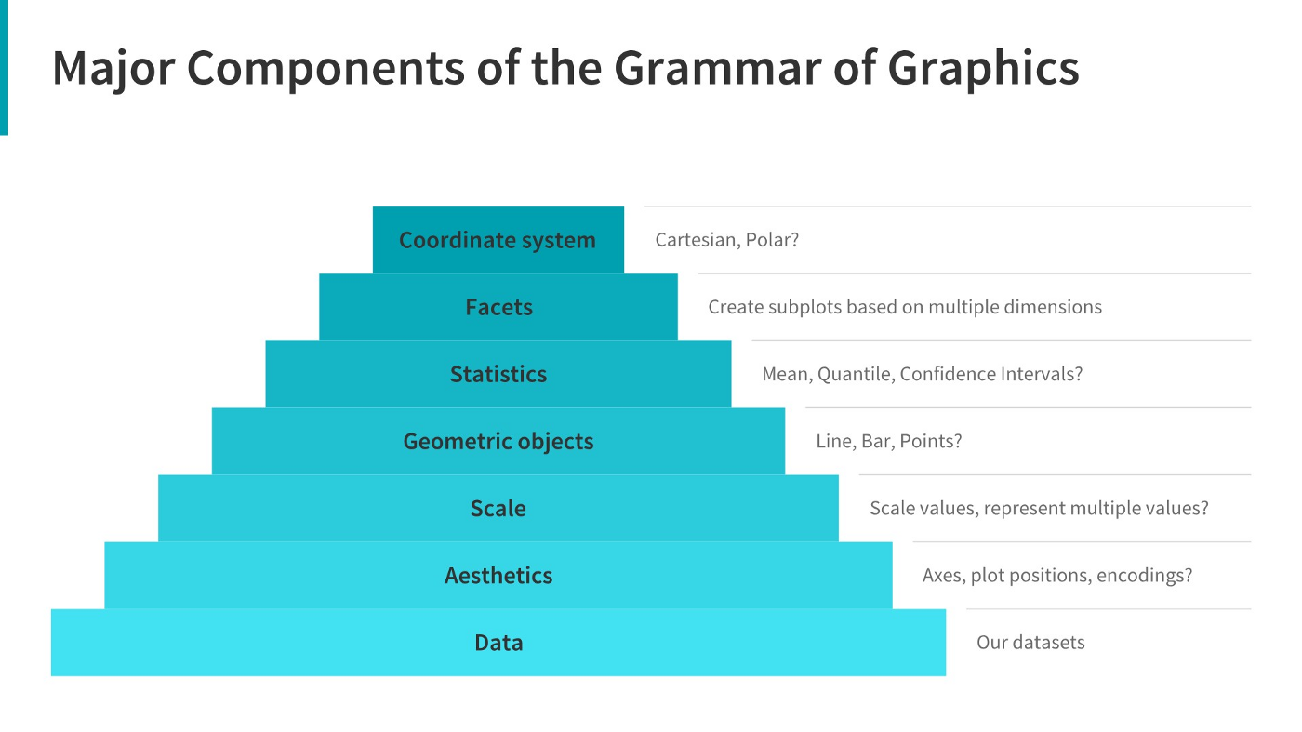

**[A Comprehensive Guide to the Grammar of Graphics](https://towardsdatascience.com/a-comprehensive-guide-to-the-grammar-of-graphics-for-effective-visualization-of-multi-dimensional-1f92b4ed4149)**

[**Click to view website →**](https://towardsdatascience.com/a-comprehensive-guide-to-the-grammar-of-graphics-for-effective-visualization-of-multi-dimensional-1f92b4ed4149)

**[How to Choose the Right Chart for Data Visualisation](https://www.analyticsvidhya.com/blog/2021/09/how-to-choose-the-right-chart-for-data-visualization/)**

**[Click to view website →](https://www.analyticsvidhya.com/blog/2021/09/how-to-choose-the-right-chart-for-data-visualization/)**

Choosing right charts based upon need such as Comparison, Distribution, Relationship, and Composition.

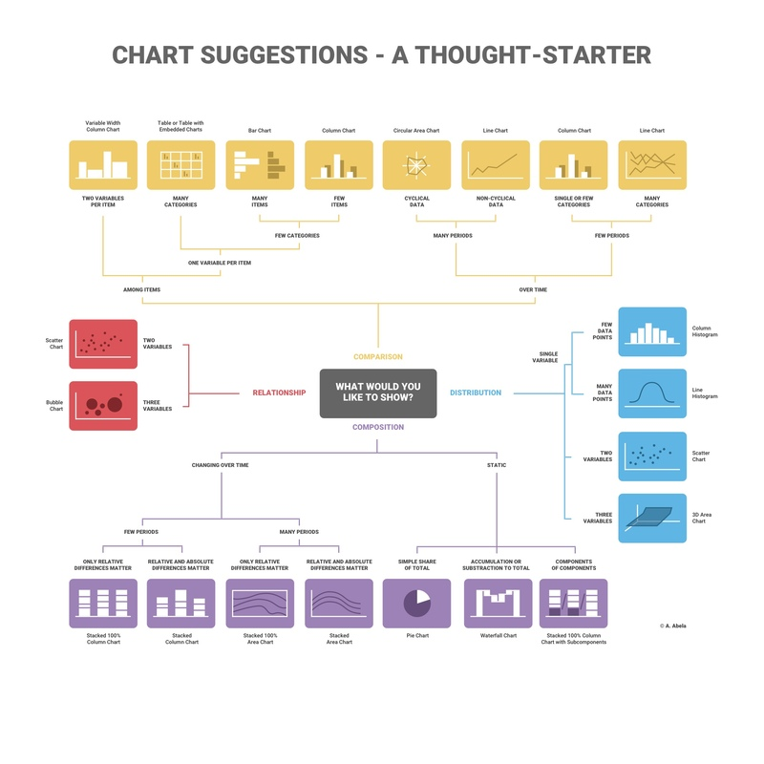

**[How to Choose the Right Chart for Your Data](https://infogram.com/page/choose-the-right-chart-data-visualization)**

**[Click to view website →](https://infogram.com/page/choose-the-right-chart-data-visualization)**

Additional Resources:

**[Ultimate Guide to Choosing the Right Visual](https://towardsdatascience.com/ultimate-guide-to-choosing-the-right-visual-2a77aa8eec08)**

[**Click to view website →**](https://towardsdatascience.com/ultimate-guide-to-choosing-the-right-visual-2a77aa8eec08)

**[How to Choose the Right Data Visualisation](https://chartio.com/learn/charts/how-to-choose-data-visualization/)**

[**Click to view website →**](https://chartio.com/learn/charts/how-to-choose-data-visualization/)

**[Which Type of Chart or Graph is Right for You?](https://www.tableau.com/learn/whitepapers/which-chart-or-graph-is-right-for-you)**

**[Click to view website →](https://www.tableau.com/learn/whitepapers/which-chart-or-graph-is-right-for-you)**

Question 1 of 5

The CEO of the retail store is interested to view the time series of the revenue data for the entire year. The CEO is interested in viewing the seasonal trends and wants to dig deeper into why these trends occur. This analysis will be helpful for the CEO to forecast for the next year. Which visual would most likely help the CEO analyse the data?

1. Bar chart
2. Line chart
3. Pie chart
4. Scatter plot

Question 2 of 5

The CMO is interested in viewing the top 10 countries which are generating the highest revenue. Additionally, as a subcomponent, they would also like to see which products are contributing to the total revenue being generated by each country. Which visual would enable the CMO to view the revenue for each country and the breakdown by products on a single chart?

1. Bar chart
2. Pie chart
3. Boxplot
4. Stacked bar chart

Question 3 of 5

The CEO of the online retail store wants to see how much average revenue is generated by each country. They are interested in viewing the following metrics on the visual: Minimum value First quartile value Median value Third quartile value Maximum value Which chart would you create to show the above metrics for the average revenue generated by each country?

1. Scatter plot
2. Histogram
3. Waterfall chart
4. Boxplot

Question 4 of 5

The CMO of the online retail store wants to view the information on the top 10 customers by revenue. They are interested in a visual that shows the greatest revenue-generating customer at the start and gradually declines to the lower revenue-generating customers. The CMO wants to target the higher revenue-generating customers and ensure that they remain satisfied with their products. Which visual would help the CMO understand the data on revenue generated by the top 10 customers?

1. Pie chart
2. Stacked bar chart
3. Column chart
4. Area chart

Question 5 of 5

Q5/5: The CEO is looking to gain insights on the demand for their products. They want to look at all countries and see which regions have the greatest demand for their products. Once the CEO gets an idea of the regions that have high demand, they will initiate an expansion strategy which will allow the company to target these areas and generate more business from these regions. He wants to view the entire data on a single view without the need to scroll or hover over the data points to identify the demand. Which chart would be most useful to provide the CEO information on the demand in each region?

1. Area chart
2. Scatter plot
3. Map chart
4. Pie chart

Q1: Option 2. A line chart is used to represent repeated measurements taken over regular time intervals. Time is always displayed on the horizontal axis and values on the vertical axis. The line chart would enable the CEO to see important changes in the data, like seasonality or cyclic behaviour, which will provide a better understanding of the revenue and help forecast better.

Q2: Option 4. A stacked bar chart would be used here as the chart allows users to compare subcomponent pieces across different categories. The height or length of the bars will represent the total revenue generated by each country. Each bar will be divided into the products sold, where the major portion will be allocated to the products that are generating more revenue. This will allow the CMO to view the total revenue data as well as the revenue for each individual product.

Q3: Option 4. The CEO’s request would best be fulfilled using a box plot. The box plot would show the distribution of data based on a five number summary (“minimum”, first quartile, median, third quartile, and “maximum”). Boxplots are used to graphically demonstrate the locality, spread and skewness groups of numerical data. Boxplots are used to graphically demonstrate the locality, spread and skewness groups of numerical data. By using the boxplot, we can easily spot outliers and the distribution of the plot.

Q4: Option 3. The CMO’s request would best be fulfilled by using a column chart. Column charts are used to display comparisons between different items. Alternatively, you can view a comparison of items over time. In this case, the column chart would display the top 10 customers who are contributing the most to revenue. The first bar on the left would be the longest one and would display information for the customer who bought the most goods from the online store. The revenue contributed by each customer would gradually decline as the bars move to the right.

Q5: Option 3. A map chart would be the best option for visuals here as it will allow the CEO to view the demand information on a single view. The map chart will have all the countries on a single map and the demand will be displayed by highlighting the area of each country. Dark highlights would mean that the countries have high demand for products whereas the countries that are highlighted light colour are the ones that have low demand. Geographical data is best visualised using map charts as they are very easy to view and the underlying values are also easy to analyse.

**Task 3: Creating Effective Visuals**

# Here is the background information on your task

The CEO and CMO have recently met to finalise the requirements and would like you to provide them with some analysis and visuals that would help answer their questions. Both, the executives are interested in viewing and understanding how they can use the data to make more meaningful decisions. You would need to provide insights which they can use to create the expansion strategy. The executives want to analyse the trends and the breakdown by different categories so that they have clarity on how the revenue is being generated and what are the main factors affecting the online store.

You will be provided with the requirements of the executives and how they want to view the data. After the requirement gathering phase, you would need to make sure that the data you are using is of good quality and does not contain any bad data that would have an adverse impact on your analysis. Once the data is cleaned, the next step would be to create the visuals on either Tableau or Power BI. No matter which tool you choose for the visuals, the result should be the same. These results will help the executives with effective decision making and assist in their expansion strategy.

# Here is your task

In this task, you will create the visuals around four of the questions that the CEO and CMO have requested. You can use either Tableau or Power BI to create the visuals and we’ve provided the data in the resources below.   
Both Power BI and Tableau have free trials that can be accessed in order to complete this task. You can find a resource below that directs you how to download these free trials.  
  
Data cleanup   
Before you can begin the analysis, make sure that the data is cleaned properly. You have noticed that the data contains some returns to the store which are provided in negative quantities and there are unit prices which were input in error. You will need to perform the following steps to clean this data.

* Create a check that the quantity should not be below 1 unit
* Create a check that the Unit price should not be below $0

Please note that in order to apply the checks that have been mentioned above, you would need to use conditional formulas where the logic would state that if the conditions are met then the tool should exclude the data from analysis. You can also use data transformation methods to get rid of the bad data. Both these methods are provided in the resources. Once this is done, the data will be good to be used for further analysis. Please note that this data should be cleaned up before attempting any question.  
  
Create each visual on a separate tab with the name of the tab displaying the question number. Once the visuals are created, save the files and upload them below.   
For Tableau users, you would need to upload in .twbx format whereas Power BI files need to be saved in .pbix format.   
Instructions on how to save in these formats are provided in the resources below.

Should you get stuck, please reference the Visuals Hints document in the resources.

Question 1  
The CEO of the retail store is interested to view the time series of the revenue data for the year 2011 only. He would like to view granular data by looking into revenue for each month. The CEO is interested in viewing the seasonal trends and wants to dig deeper into why these trends occur. This analysis will be helpful for the CEO to forecast for the next year.

Question 2  
The CMO is interested in viewing the top 10 countries which are generating the highest revenue. Additionally, the CMO is also interested in viewing the quantity sold along with the revenue generated. The CMO does not want to have the United Kingdom in this visual.

Question 3  
The CMO of the online retail store wants to view the information on the top 10 customers by revenue. He is interested in a visual that shows the greatest revenue generating customer at the start and gradually declines to the lower revenue generating customers. The CMO wants to target the higher revenue generating customers and ensure that they remain satisfied with their products.

Question 4  
The CEO is looking to gain insights on the demand for their products. He wants to look at all countries and see which regions have the greatest demand for their products. Once the CEO gets an idea of the regions that have high demand, he will initiate an expansion strategy which will allow the company to target these areas and generate more business from these regions. He wants to view the entire data on a single view without the need to scroll or hover over the data points to identify the demand. There is no need to show data for the United Kingdom as the CEO is more interested in viewing the countries that have expansion opportunities.

## Here are some resources to help you

**[Downloading Power BI & Tableau](https://cdn.theforage.com/vinternships/companyassets/ifobHAoMjQs9s6bKS/5XsFFJu2oCLdmYJW2/1657136958931/Power%20BI%20-%20Tableau%20Downloads.pdf)**

**[Click to download file →](https://cdn.theforage.com/vinternships/companyassets/ifobHAoMjQs9s6bKS/5XsFFJu2oCLdmYJW2/1657136958931/Power%20BI%20-%20Tableau%20Downloads.pdf)**

**[Online Retail Data Set](https://cdn.theforage.com/vinternships/companyassets/ifobHAoMjQs9s6bKS/5XsFFJu2oCLdmYJW2/1654309626143/Online%20Retail%20Data%20Set.xlsx)**

**[Click to download file →](https://cdn.theforage.com/vinternships/companyassets/ifobHAoMjQs9s6bKS/5XsFFJu2oCLdmYJW2/1654309626143/Online%20Retail%20Data%20Set.xlsx)**

Available from: Daqing Chen, Sai Liang Sain, and Kun Guo, Data mining for the online retail industry: A case study of RFM model-based customer segmentation using data mining, Journal of Database  
Marketing and Customer Strategy Management, Vol. 19, No. 3, pp. 197â€“208, 2012  
(Published online before print: 27 August 2012. doi: 10.1057/dbm.2012.17).  
https://archive.ics.uci.edu/ml/citation_policy.html

**[Resources - Tableau and Power BI](https://cdn.theforage.com/vinternships/companyassets/ifobHAoMjQs9s6bKS/5XsFFJu2oCLdmYJW2/1654132626672/Resources%20-%20Tableau%20and%20Power%20BI.pdf)**

**[Click to download file →](https://cdn.theforage.com/vinternships/companyassets/ifobHAoMjQs9s6bKS/5XsFFJu2oCLdmYJW2/1654132626672/Resources%20-%20Tableau%20and%20Power%20BI.pdf)**

**[Visuals Hints](https://cdn.theforage.com/vinternships/companyassets/ifobHAoMjQs9s6bKS/5XsFFJu2oCLdmYJW2/1654309786280/Visuals%20Hints.pdf)**

**[Click to download file →](https://cdn.theforage.com/vinternships/companyassets/ifobHAoMjQs9s6bKS/5XsFFJu2oCLdmYJW2/1654309786280/Visuals%20Hints.pdf)**

# Example Answer

Great work! Take a look at the example answer below to see how a professional would have attempted this task. Think about what you did well and how you can improve.

**[Tableau and PowerBI Files](https://cdn.theforage.com/vinternships/companyassets/ifobHAoMjQs9s6bKS/5XsFFJu2oCLdmYJW2/1693957649968/Model%20Answer-Task%203.zip)**

**[Click to download file →](https://cdn.theforage.com/vinternships/companyassets/ifobHAoMjQs9s6bKS/5XsFFJu2oCLdmYJW2/1693957649968/Model%20Answer-Task%203.zip)**

**Task 4: Communicating Insights and Analysis**

# Here is the background information on your task

It’s time to present your findings to the CEO and CMO. They are interested in your thought process and how you have handled the data cleanup and visualisation phase. It is important to explain your thought process and ideas in a clear and straightforward way. You are also required to clearly present the analysis of all four questions from the previous task. Make sure you are well versed with the data and the conclusions you’ve made from your analysis.

Expansion is top of mind for these leaders and they’re keen to understand where the most lucrative opportunities are in their business.

Some resources to help guide you in communicating data effectively are provided in the resources section below.

# Here is your task

Develop a script and record a video presenting your findings to the CEO and CMO based on the four questions they asked and the visuals you created in the previous tasks.

You can use your work or the model answer from the previous task to develop your presentation.

When writing your script, you should speak about your entire process, including the initial data load and clean-up steps so that your leaders know you’ve done your due diligence in providing error-free analysis.   
Data analysis provides heaps of information but remember to focus on the information that is most important to your leaders.

Your video should be approximately 5 minutes in length. You can record your video in the browser or upload a video from your device below.

Remember, this is not just a read out of your visuals, you’re presenting to the CEO and CMO and need to provide context for each scenario and how it relates to their questioning.

You do not need to submit your script or talking points for this deliverable.

## Here are some resources to help you

Task 3 Model Answers:

**[Power BI Visuals](https://cdn.theforage.com/vinternships/companyassets/ifobHAoMjQs9s6bKS/5XsFFJu2oCLdmYJW2/1657244648783/Data%20Visualisation-Empowering%20Business%20with%20Effective%20Insights-PowerBI.pdf)**

**[Click to download file →](https://cdn.theforage.com/vinternships/companyassets/ifobHAoMjQs9s6bKS/5XsFFJu2oCLdmYJW2/1657244648783/Data%20Visualisation-Empowering%20Business%20with%20Effective%20Insights-PowerBI.pdf)**

**[Tableau Visuals](https://cdn.theforage.com/vinternships/companyassets/ifobHAoMjQs9s6bKS/5XsFFJu2oCLdmYJW2/1657244683310/Data%20Visualization%20Tableau%20Dashboard%20-%20Empowering%20Business%20for%20effective%20insights.pdf)**

**[Click to download file →](https://cdn.theforage.com/vinternships/companyassets/ifobHAoMjQs9s6bKS/5XsFFJu2oCLdmYJW2/1657244683310/Data%20Visualization%20Tableau%20Dashboard%20-%20Empowering%20Business%20for%20effective%20insights.pdf)**

Additional Resources:

**[InsideBigData - A Data Scientist’s Guide to Communicating Results](https://insidebigdata.com/2018/03/28/data-scientists-guide-communicating-results/)**

**[Click to view website →](https://insidebigdata.com/2018/03/28/data-scientists-guide-communicating-results/)**

**[Analysing Data and Communicating Results](http://elearning.daremightythings.com/CCF/analyzingdata/Print.aspx)**

**[Click to view website →](http://elearning.daremightythings.com/CCF/analyzingdata/Print.aspx)**

**Video Recording info:**

**Greeting & Introduction:**

* “Good [morning/afternoon], CEO and CMO. Thank you for giving me the opportunity to present the findings of my analysis today. My name is [Your Name], and I’ve been tasked with analyzing key data that could help us improve the business’s performance, as well as support the strategic planning for next year. I will walk you through the data analysis process, the visuals I've created, and the insights I've derived, which I believe will help guide the business in its expansion strategy and improve operational efficiency.”

### **Process Overview**

**Data Load & Cleanup:**

* “I began by loading the provided online retail dataset. Upon review, I noticed some issues with the data—particularly some negative quantities and erroneous unit prices, which I addressed in the data cleaning phase. I used conditional checks to remove any rows where quantities were below 1 or the unit prices were below $0. This ensured that the data I was working with was clean and accurate for analysis.”

**Data Transformation:**

* “I also used data transformation methods to ensure consistency across product categories and revenue columns. This allowed me to create reliable and meaningful visualizations for your questions.”

### **Visual Analysis & Insights**

**Question 1: Time Series of Revenue for 2011**

* “The first question I focused on was from the CEO, who wanted to understand the seasonal revenue trends for 2011. I created a time series line chart that shows revenue for each month throughout the year. As you can see, the chart highlights clear peaks and valleys, which indicate seasonal demand fluctuations. We can infer that during certain months, likely due to holidays or promotional events, there were significant spikes in revenue. This kind of analysis is crucial for forecasting next year and planning for optimal promotional periods.”

**Key Insight for CEO:**

* “Understanding these patterns helps us prepare for the next year, ensuring we are ready for demand peaks and can optimize marketing efforts during these times.”

**Question 2: Top 10 Countries Generating Highest Revenue**

* “Moving on to the CMO’s question about the top 10 countries by revenue, excluding the United Kingdom. I created a bar chart that ranks the countries by revenue and also shows the quantity sold in each country. This chart helps us identify which regions are driving the most revenue. For example, countries like the USA and Germany are at the top of the list. The inclusion of quantity sold in the same chart gives us further insights into market demand. This is helpful for targeting regions with high sales volume for continued growth.”

**Key Insight for CMO:**

* “By focusing on the countries with the highest revenue and quantity sold, we can refine our marketing efforts and allocate resources where they’ll have the most impact.”

**Question 3: Top 10 Customers by Revenue**

* “The CMO also asked for information on the top 10 customers by revenue. I’ve used a column chart to show this, with the highest revenue-generating customers on the left side and gradually declining to the lower revenue-generating customers. This visual allows us to quickly identify key customers who contribute the most to our sales and highlights the importance of retaining these clients.”

**Key Insight for CMO:**

* “Targeting and maintaining relationships with high-value customers will be crucial to sustaining and growing our revenue. The visual also provides insight into customer segmentation and where personalized marketing efforts could be most effective.”

**Question 4: Demand Across Regions**

* “Finally, the CEO wanted to know which regions have the highest demand for products. I created a map chart to display demand by region, excluding the United Kingdom. The map provides a clear, easily digestible visual of product demand across the globe. Regions like North America and parts of Europe show higher demand, while other areas show lower levels. This insight is vital for the upcoming expansion strategy.”

**Key Insight for CEO:**

* “With this map, we can pinpoint regions with high demand and focus our expansion efforts there, ensuring that we capture the maximum market potential and make informed decisions about where to direct resources for business growth.”

### **Conclusion & Recommendations**

* “In conclusion, the data analysis has provided valuable insights for both the CEO and CMO. The seasonal trends in revenue allow us to plan for next year with more confidence. The country and customer insights will help focus our marketing efforts and improve customer retention. Finally, the demand map allows us to identify regions for expansion, ensuring that we target high-demand areas for growth.”

**Closing Remarks:**

* “I’m confident that these insights will be crucial in making strategic decisions as we move forward. I look forward to collaborating with the team to take these findings and drive the business toward continued success. Thank you for your time, and I’m happy to answer any questions you may have.”

### **Recording Tips**

* **Keep your tone clear and confident.**
* **Maintain eye contact** by looking at the camera.
* **Speak at a moderate pace** so the information is easy to follow.
* **Use pauses** to allow the CEO and CMO to absorb the insights.
* **Ensure good lighting and minimal background noise** for a professional video.

# Example Answer

Great work! Take a look at the example answer below to see how a professional would have attempted this task. Think about what you did well and how you can improve.

Sample Video Script

Good Afternoon,

I’m [insert name], and I’m excited to share some insights about your business. Thank you for  
providing the guiding questions. It was helpful to see what types of insights you are looking to  
gain from the data. I hope you find the analysis compelling and helpful as you make decisions  
regarding future business opportunities.

First off, I want to assure you that I’ve provided the most up to date and error free analysis. After  
I loaded the data into my software, I scrubbed any records that have negative quantities and  
unit price, as these records needed to be removed in order to provide helpful analysis.

As for your first question, the CEO has requested a trend of the revenue to see if there is any  
seasonality in the store sales. My analysis shows that there are some months of the year where  
exceptional growth is witnessed. The data shows that the revenue in the first 8 months is fairly  
constant as the average revenue generated for these 8 months is around $685k. The increase  
in revenue starts in the month of September, where the revenue increases by 40% over the  
previous month. This trend continues till the month of November where it reached 1.5 million  
USD, the highest during the entire year. The data is incomplete for the month of December,  
therefore, no conclusion can be drawn from it, unfortunately. This analysis shows that the retail  
store sales are impacted by the seasonality which usually occurs in the last 4 months of the  
year.

The second visual shows how the top 10 countries which have opportunities for growth are  
performing. This data does not include the UK as the country already has high demand and I’ve  
been told you’re more focused on the countries where demand can be increased. The analysis  
shows that countries such as the Netherlands, Ireland, Germany and France have high volumes  
of units bought and revenue generated. I would suggest that these countries should be focused  
on to ensure that measures are taken to capture these markets even more.

The third analysis has been performed on the top 10 customers who have purchased the most  
from the store. The data shows that there is not much of a difference between the purchases  
made by the top 10 customers. The highest revenue generating customer only purchased 17%  
more than the 2nd highest which shows that the business is not relying only on a few customers  
to generate the revenue. This shows that the bargaining power of customers is low and the  
business is in a good position.

Finally, the map chart shows the regions that have generated the most revenue compared with  
the regions that have not. It can be seen that apart from the UK, countries such as Netherlands,  
Ireland, Germany, France and Australia are generating high revenue and the company should  
invest more in these areas to increase demand for products. The map also shows that most of  
the sales are only in the European region with very few in the American region. Africa and Asia  
do not have any demand for the products, along with Russia. A new strategy targeting these  
areas has the potential to boost sales revenues and profitability.

Thanks so much for your time. If you have any questions about the analysis or would like to see  
anything additional after you’ve had time to digest this information, I’d be happy to develop that  
for you.